AN ALTERNATIVE GRIND FOR THE SKEW CHISEL
Alan Lacer

Geometry: 70 degrees from point to point; ground bevel angle (equivalent to bevel length) is expressed as 1.5 x steel thickness; behind the short point’s bevel a full round to the end of the blade; behind the long point’s bevel a flattened surface but with the corners removed.

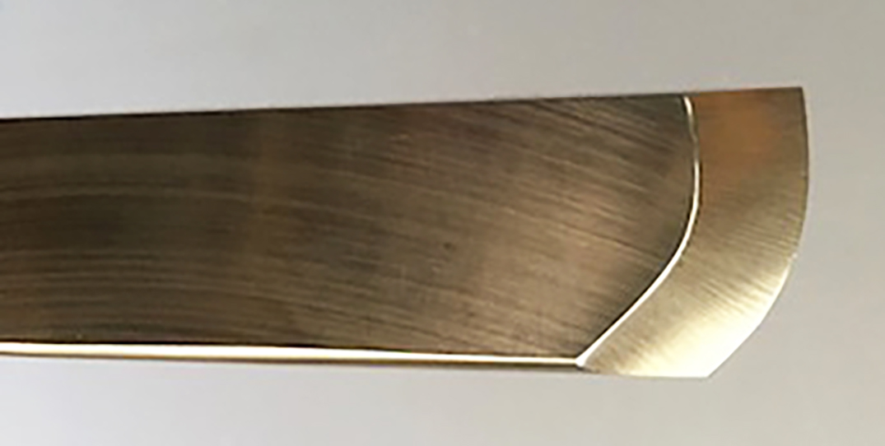

ADVATAGES:
- “Tells” you where to cut for planing and rolling cuts (cut where curved)
- For planning and rolling cuts gives increased clearance angle for the trailing point and trailing edge
- Gives between 15% and 20% more cutting edge
- For peeling cuts is self-limiting
- For peeling cuts puts the handle at a right angle to the axis of lathe
- Straight section used for scraping actions
- Straight section used for finishing cuts on rounded pommels
- Curved edge works better on “chippy” or figured woods
9. Curved edge has lower impact when planning or rolling, has a progressive entry into the wood, better at shearing the fibers
10. Curved edge works better for concave cuts (a curve fits a curve better)

DISADVANTAGE: Harder to sharpen than a traditional ground skew.
For sharpening two sizes of skews with this grind see Alan on YouTube:
https://www.youtube.com/watch?v=dmCxDToHm6Y&t=19s

